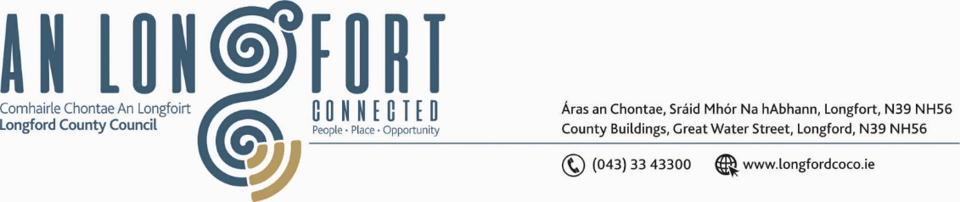

***BALLYMAHON MUNICIPAL DISTRICT***

***Please note meeting will be held in Ballymahon Library and via Microsoft Teams.***

**17th September 2021.**

**To: Each Member of Ballymahon Municipal District.**

**Dear Member,**

You are requested to attend a Meeting of Ballymahon Municipal District to be held

**in Ballymahon Library and via Microsoft Teams** on **Thursday, 23rd September 2021 at 4pm** to transact business, as set out on the Agenda hereunder.

**Yours sincerely**,

Ann Marie Mc Keon

_______________

**Ann Marie Mc Keon,**

**Meetings Administrator.**

**AGENDA**

Prayer before meeting.

**1.** (i) Confirmation of Minutes of Ballymahon Municipal District Meeting held on

the 22nd July 2021 – copy enclosed.

(ii) Confirmation of Minutes of Ballymahon Municipal District Committee Meeting held on the 3rd September 2021- copy enclosed.

**2.** Matters arising from Minutes.

**3.** Declaration of Interest by Members.

**4.** Management Report - enclosed.

**5.** Lanesborough-Ballyleague Economic and Enterprise Development Strategy. (Presentation to follow).

**6.** Proposed Projects/Expression of interest – enclosed.

**7. Notices of Motions, submitted by Councillors, as listed hereunder –**

**Councillor Gerard Farrell**

I call on Longford County Council roads department to resurface the carpark area at Cashel cemetery.

**Councillor Mick Cahill**

(i) I call on Longford County Council to carry out works at the Junction of the R399 and the L1105 (Belton’s) cross to improve sight lines in the interests of Road Safety.

(ii) I call on Longford County Council to carry out remedial works on the walls of the bridge at Belton’s Colehill and the bridge at the Hazelwood houses in Colehill in the interests of safety.

**Councillor Paul Ross**

(i) I call on Longford County Council to secure funding for a pedestrian pathway between Ardagh village and St Patrick’s GAA grounds, this is especially necessary now since the redevelopment of the community facilities at the GAA grounds.

(ii) I call on Longford County Council to allocate funding to repair the bridge at Belton’s cross Colehill in the interest of public safety.